# Executive Summary

### Exploration of the Deep Ocean with Teams of Long-Endurance Ocean Robots

# M. Jakuba1, S. Webster3, J. Partan1, E. Fischell1, C. German2

1Woods Hole Oceanographic Institution, Department of Applied Ocean Physics and Engineering

2Woods Hole Oceanographic Institution, Department of Geology and Geophysics

3University of Washington Applied Physics Laboratory, Dept. of Env. & Information Systems

As little as 5%-10% of the global ocean interior and seafloor has been explored in detail. Long endurance marine robots represent a compelling technological means to expand the scope and rate of exploration, if certain technological hurdles can be overcome. Multi-month endurance removes the virtual tether between an ocean robot and an expensive support vessel. Cost decreases as a result, and reduced reliance on ships enables access to remote regions largely unexplored because of the difficulty of access. Floats and autonomous underwater gliders (AUGs) together have enabled global-scale monitoring of the upper 1000 m of the water column; however, extending the reach of these and other long-endurance platforms into the deep water-column and to the deep seafloor poses significant technological challenges, of which navigation is one of the most difficult. Exploration activities rely on good navigation. Without good navigation it is difficult to create good maps, to accurately georeference survey products, or to accurately revisit or target small-scale water column or seafloor features.

Collaborative teams of long endurance robots are a potential solution to this problem. Accordingly, we have been developing the key enabling hardware for a new multi-vehicle acoustic navigation system through an NSF OTIC grant that will allow low-power subsea vehicles to locate themselves relative to a surface vehicle whose geographic position is known. We expect to improve the navigation of AUGs in the deep ocean by at least an order of magnitude, relative to present methods that rely on dead-reckoning between surface GPS fixes spaced hours apart (10s of hours for very deep-diving systems). In this proposal we seek support for the opportunity to deploy and demonstrate this novel capability using an array of long-endurance and untended robotic vehicles, a critical step toward transitioning the technology to the wider ocean exploration community. The proposed work will address the coordination of multiple long-endurance subsea vehicles as well as produce an end-to-end month-long field demonstration to comprehensively map methane seep activity along a 100 km portion of the continental margin in the northern Gulf of Mexico. The field campaign will yield the robust statistical measures of navigation and coverage performance necessary to assess the suitability of the approach more broadly.

This project will deliver a valuable new deep-water exploration capability and transferrable technological innovations that directly address NOAA OER’s goals of *baseline characterizations of unknown or poorly known ocean areas*, and of *advancing undersea technical capabilities*.

A total of $673951 is requested, split $350,980/$322,971 between years 1 and 2.

# Project Description

## Introduction

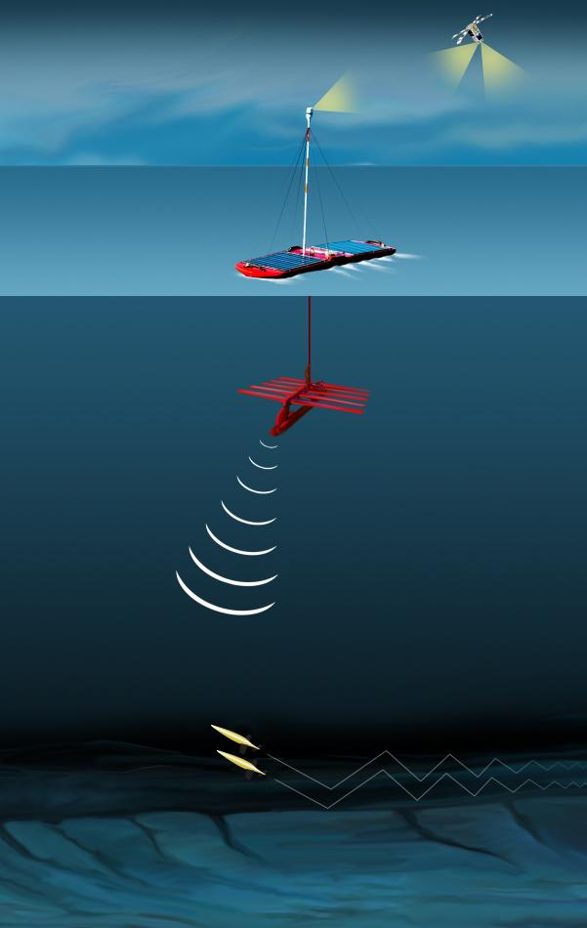

Figure 1 The multi-robot long-range exploration system envisioned in this proposal. A Waveglider ASV provides navigational aiding and mission updates to two submerged Seaglider AUGs performing high-resolution water column mapping.

As little as 5-10% of the global ocean interior and seafloor has been explored in detail [see, e.g., German et al., 2011]. The current paradigm, of using large expensive research vessels engaged in month-long expeditions focused primarily on hypothesis-driven process studies, limits basic exploration to opportunistic efforts usually confined to relatively well-studied regions. Furthermore, it is difficult to deploy ships to the most remote parts of the ocean, such as the central South Pacific or Southern Ocean, which represent some of the largest and, hence, most representative environments for both life and biogeochemical cycling in the deep ocean [Hand & German, in press]. Long-range robotic platforms, divorced from the need for a nearby research vessel, could dramatically reduce the cost of certain kinds of exploration, especially preliminary characterization ahead of sample collection, and remove the cost barrier that currently prevents routine access to remote regions of the oceans. With reduced ship and personnel cost, comprehensive high-resolution mapping of large swaths of the sea floor or global-scale features like the Mid-Ocean Ridge could become a reality [German et al., 2012]. The challenge to realizing this vision is technological, but key foundational technologies already exist or are currently in development, including by this research team.

To realize the benefits of ship-free operation, robotic platforms must ultimately possess long endurance and range (months, 1000s km) and high reliability as well as deep-ocean depth capabilities. An increasing array of autonomous underwater gliders (AUGs), autonomous underwater vehicles (AUVs), and autonomous surface vessels (ASVs) that approach and/or meet these requirements, and, considering the powerful financial incentive, it is reasonable to assume that trend will continue. Exclusive of the continental shelves, exploring the near-seafloor environment requires a depth rating of several thousand meters. Long range AUGs and AUVs with depth ratings of 1000 m are in widespread use and 6000 m systems are operational [Osse et al., 2007; Furlong et al., 2007]. To be of most value, exploration of the deep ocean also requires navigation to a quality that is commensurate with the spatial and temporal scales of the phenomenon of interest. Whereas many large-scale physical oceanographic questions impose no requirement beyond navigational accuracy to a few kilometers, high-resolution seafloor bathymetric mapping requires high-fidelity dead-reckoning (<0.1% distance traveled) combined with acoustic aiding accurate to better than 10 m. It is difficult, however, to reconcile the need for good navigation with the severe constraints on power consumption inherent to long range subsea vehicles. Conversely, vehicles operating on the surface have access to extremely low-power meter-scale GPS positioning. Collaborative teams of long endurance robots are a potential solution to this problem. Accordingly, we have been developing a new multi-vehicle acoustic navigation system over the past 12 months through an NSF OTIC grant that will allow subsea vehicles to locate themselves relative to a surface vehicle whose geographic position is known (Fig. 1). The system leverages the continuing miniaturization of MEMS-based attitude sensors, the advent of chip-scale atomic clocks (CSACs) [Gardiner and Collins, 2012], and maturity of miniature acoustic modems with powerful on-board processing [Gallimore et al., 2010, Freitag et al., 2005] into an architecture compatible with operation on low-power platforms.

In this proposal we seek support for the opportunity to deploy and demonstrate this novel capability using an array of long-endurance and untended robotic vehicles. Our project will operate this multi-vehicle suite in an exploration-based mode, to comprehensively map methane seep activity along a 100 km long section of the continental margin in the northern Gulf of Mexico. A key metric for success will be the demonstration of the potential for these next-generation technological elements, when operating in concert, to help reduce and ultimately remove the need for support ships in certain kinds of large-scale robotics-based ocean exploration. Specifically, we will seek to demonstrate the potential for ship-free seep localization and characterization, greatly accelerating the rate of ocean exploration along continental margins (e.g. within the US Exclusive Economic Zone) and, as deeper-rated vehicles become available, expanding out to the global ocean. We have already been funded to integrate one of our navigation units into a single Seaglider AUG, and to conduct sea trials with a ship-mounted acoustic source. In the project proposed here, we seek to take the logical next step required for the maturation and progression of this technology toward routine adoption by the US Ocean Exploration community. Specifically, this proposed work will demonstrate the coordination of multiple long-endurance vehicles as well as produce an end-to-end field demonstration, one-month long, that will provide us with the robust statistical measures of vehicle navigation and water column and seafloor survey coverage necessary to advance this approach more broadly.

Though AUGs do not typically carry bathymetric mapping sonars or cameras, the potential for AUGs as deep ocean exploration assets is significant, especially if well-navigated, and this potential extends beyond cost-effective operation over large or remote areas. Importantly, we also note that the seafloor mapping capabilities *have* been demonstrated already in at least certain key instances [Zapata et al., 2016, Claus and Bachmeyer 2015; Claus and Bachmeyer 2012]. More generally, however, AUGs are proven in terms of their capabilities to make water column observations, (e.g. CTDs for basic physical oceanographic parameters), but the ever increasing array of small and low-power in situ sensors under development, with ever-increasing sensitivity and discriminatory power, will only expand the range of biogeochemical parameters that it will be possible to measure in situ and at high spatial resolution in the ocean. For example, Camilli [2017] has recently reported deployment of a bespoke low-power mass spectrometer on an AUG. Such sensors will allow the preliminary characterization, in situ, of seep sites, hydrothermal vents, and even oil-spills from AUGs with suitable depth ratings. Indeed, preliminary demonstrations using AUGs equipped with hydrocarbon sensors have already demonstrated the future potential to use AUGs in resource-based exploration and surveys [Alseamar, 2017]. In the future, all robotics-based ocean exploration efforts (both public- and privately-funded) will require the precise deep navigation capabilities that we seek to pioneer here. Without such navigation, it will be impossible to return to key sites of interest, detected autonomously, to conduct more detailed scientist-led (e.g. ROV based) exploration.

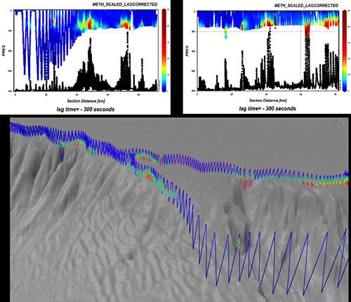

Figure 2: Glider transects showing water-column methane associated with seafloor seeps along a continental margin [Alseamar, 2017].

## Scientific Merit

The discovery of chemosynthetic ecosystems associated with seafloor fluid flow, first at hydrothermal vents in 1977 [Corliss et al, 1979], and then at cold seeps in 1983 [Paull et al, 1983], has been widely recognized as one of the most exciting discoveries across *all fields of research* in the 20th Century. We now know that these features are pervasive and globally distributed; however, while we know that *examples* of such systems occur in every ocean basin [e.g. Baker & German, 2004; Beaulieu et al., 2013] we are far from having a global catalog of sites, much less baseline characterizations of each site’s geologic setting or their associated biological communities [German et al., 2011]. Likewise, we have long recognized that we lack sufficient understanding of either the global distributions of such seafloor-fluid systems or the biogeochemical fluxes that they impart to the overlying ocean to fully understand, and include in global modelling efforts, the role that such systems contribute to the larger Earth System. What our most recent research *has* demonstrated, however, is that we cannot assume that seafloor fluid flow is so deep and so remote that it is insignificant at the planetary scale. Rather, new work has indicated that up to 30% of primary productivity in the upper layers of the Southern Ocean may be regulated by the flux of hydrothermally-sourced iron, acting as a productivity-limiting micronutrient sourced from below [Resing et al., 2015]. It is extremely timely, therefore, to accelerate the rates with which we can explore the deep ocean for seafloor fluid flow systems and investigate the roles they play in global-scale ocean biogeochemical cycles [German et al., 2016, Levin et al., 2016].

The first hydrothermal vents were discovered serendipitously by camera sled, and the first cold seeps similarly but by submersible. Subsequently, exploration for high temperature hydrothermal activity has flourished with the recognition that non-buoyant hydrothermal plumes emplaced hundreds of meters above their vent-sources at the seafloor can be dispersed long distances through the oceans and detected, routinely, through *in situ* sensing (see, e.g., [Baker & German, 2004; Baker et al., 2016]). By contrast, the rate of discovery for cold-seep systems languished over multiple decades, for want of a systematic method for cold seep exploration. At Blake Spur as recently as Summer 2012, for example, our results using the AUV Sentry deployed from the Okeanos Explorer were considered remarkable because they doubled the total number of cold seep systems known anywhere along the Atlantic margin, from 2 to 4 [Brothers et al., 2013; Wagner et al., 2013]. Twelve months later, our understanding of the abundance of cold seeps and, hence, their potential impact on the global dissolved methane cycle in the oceans, was revolutionized with the demonstration, using the Okeanos Explorer’s multibeam mapping sonars to image bubble streams, that there were not just for, but in excess of 400, cold seep systems along the same stretch of the Atlantic margin [Skarke et al., 2014].

This is extremely important. It is understood that dissolved methane released from the seafloor in this way can escape to the atmosphere as a potent greenhouse gas [McGinnis et al., 2006], and contribute to both ocean acidification and deoxygenation [Biastoch et al., 2011; Archer et al., 2009] as well as fuelling chemosynthetic ecosystems at the seafloor. While shipboard acoustic techniques have revolutionised our ability to identify and rapidly begin to localize sites of gas-rich seafloor fluid flow, there are two important limitations to the current state of the art that we seek to address in this proposal. First, as one extends from the continental shelf-break, down-slope to ever greater depths, the separation from the ship’s sonar system at the surface to the source of acoustically resonant bubble plumes increases and so too, as a consequence, does our ability to predict the precise location of any sources on the seafloor. Second, acoustic detection of cold seep effluent is contingent upon the presence of gaseous material - any dissolved methane (likely a higher proportion of the total flux from any given site at increasing pressure/depth) is potentially invisible to such detection techniques. We know that such fluxes must occur, however, because our AUV Sentry based studies at cold seeps *have* documented in situ chemical anomalies, even in the absence of any signs of bubble evolution, at cold seep chemosynthetic ecosystem sites in all of: the Atlantic Margin [Wagner et al., 2013], the Haakon Mossby mud volcano [Feseker et al., 2014], the Gulf of Mexico [Fisher et al., 2014] and the California Borderlands [Valentine et al., 2010].

What we propose here, therefore, is a technological demonstrator field program that will seek to establish new approaches to routinely address two key problems.

First, we will improve our capability to track cold seeps whose presence can be detected from acoustic water column anomalies to their seafloor source. To illustrate the size of this problem and its scientific need: the vast majority of the >400 seep sites that have been identified between Cape Hatteras and the Hudson Canyon, have never been located precisely, and nor would it be feasible to do so following the current state of the art: exhaustive ship-based ROV-surveys. If one can precisely locate sources at the seafloor however, in a range of distinct geologic settings, then a better-informed and more effective future exploration program can be developed, to investigate a carefully selected and targeted suite of such sites using high-value ship/ROV assets.

Second, by mounting proven *in situ* dissolved methane sensors on the 1000 m rated gliders to be used in this project, we will not only be able to track sources of methane to their origin at the seafloor but also to investigate the dispersion and fate of the previously “missing” or overlooked dissolved methane flux, using those same gliders’ abilities to survey more efficiently than an AUV through the overlying water column and to traverse long distances. The strategy we propose will represent a great improvement over the current state of the art (lowering CTD casts vertically from the ship and collecting samples for shipboard dissolved CH4 analyses - see, e.g. [Bennett et al., 2013].

The work we propose here will already represent an important step forward, in extremely timely fashion, in response to our newly-revealed ignorance about the presence of a previously overlooked but significant flux of methane to the oceans along the US (and presumably all) continental margins [Skarke et al., 2014]. Looking further ahead, however, the advent of a wider range of *in situ* sensors and greater depth capabilities offer wider applications. For example, recent work using *in situ* redox sensors has revealed that there may be a significant flux of hydrothermal activity along Mid-Ocean Ridges that is not detectable from in situ optical back-scatter alone, meaning that much of our understanding of the distribution of venting may need to be revisited [Baker et al., 2016]. Just as acoustic sensing can only detect the acoustically resonant subset of all methane rich fluid-flow sites along ocean margins, our historic approaches may only have revealed a subset of all hydrothermal vent-sites. The need for a more efficient way to revisit that work is compelling. Further, as we become increasingly aware that seafloor fluid flow can impact the biogeochemical cycle of the oceans [Resing et al., 2015; German et al., 2016] we urgently need new mechanisms not only to trace those materials as they are dispersed through the deep ocean but, to understand the processes that modify the gross fluxes from the seabed into the effective fluxes delivered to the ocean. It is increasingly apparent that we need to track those materials, with faithful navigation, at any ocean depth even far above the seafloor, out to distances of 10-100 km from their source. Our technological program, detailed below, will provide that.

## Technical Merit

Technological developments over the past two decades have provided US scientists with an impressive array of new deep-diving and long-endurance vehicles, including autonomous underwater gliders (AUGs) [Stommel, 1998; Webb et al., 2001; Eriksen et al., 2001], autonomous underwater vehicles (AUVs), e.g., [Allen et al., 1997, Bradley and Yoerger, 1993; Griffiths, 2005; , 17, 49, 23], long-range AUVs (LRAUVs) [Furlong et al., 2007, Bellingham et al., 2010], and autonomous surface vessels (ASVs) [Hine et al., 2009; Meinig et al., 2015]. These vehicles, equipped with the relevant sensor packages and with increasing scales of autonomy, can reasonably be expected to provide coverage suitably global in scale for future science needs. The low power consumption of these vehicles, particularly AUGs, is critical to their long-endurance and consequent potential for autonomous global-scale exploration, but also introduces certain limitations. Perhaps the most significant of these is navigation. Low-power operation prohibits using the high-power inertial measurement units and Doppler velocity logs (DVLs) that have become standard components in the navigational suite of bathymetric mapping AUVs (e.g., [Kinsey et al., 2004, 97, Griffiths, 2005]). These sensors each consume well over 10 W but can deliver an internal estimate of position accurate to within 0.1% of distance traveled [Brokloff, 1997l Whitcomb et al., 1999; Kinsey et al., 2011] that can be further improved using various forms of external acoustic aiding, typically supplied either by fixed seafloor beacons [Hunt et al., 1974; Milne, 1983] or a tending vessel [Singh et al., 2006, Smith at Kronen, 1997, Audric, 2004; Parthiot 1993; Obderbecke, 1997].

In contrast, an AUG’s small size and miserly power budget (< 1 W) precludes using many of the sensors used by larger AUVs and the sensors it does carry must be low power. Typically, GPS is the only navigation aiding method available and can only be used on the surface. While submerged, AUGs rely on internal dead-reckoned position estimates based on velocities from a hydrodynamic vehicle model. However, the quality of these estimates depends on the fidelity of the models and cannot account for external forces, water currents in particular. In fact, water currents are estimated as the discrepancy between the expected model-based surfacing location and GPS, yielding a single vector representing depth-averaged current, which is itself subject to the accuracy of the model for the AUG's hydrodynamics. Consequently, the internal navigation error of a glider is high -- [Claus et al., 2010] report errors of 13% of distance traveled while [Smith et al., 2010] report 50% of distance traveled. The result is navigation errors on the orders of 1-10km, with error increasing the longer an AUG stays submerged. Traditional acoustic navigation methods are not feasible as they suffer from two deficiencies: (1) the glider must acoustically transmit (which incurs a significant energy penalty); and (2), as in the AUV case, it requires costly external infrastructure. As a result, the status quo is to operate gliders without any subsea navigational aiding. There are a few examples of acoustically aided subsea AUG navigation [Webster et al., 2014; Webster et al., 2015, Freitag et al., 2015] that use range measurements from multiple sources. But even in these cases the positional accuracy is orders of magnitude worse than GPS, and position fixes are only available once every several hours. While navigation errors of this magnitude are sufficient for the water-column physical oceanographic studies and monitoring for which gliders were originally designed, the growth in navigation error with depth precludes using gliders as deep ocean exploration assets. Poor navigation produces poor maps, but also precludes accurately targeting known features and compromises the ability of a vehicle to fly georeferenced search or survey patterns. The use of gliders in an exploration capacity has, therefore, been almost non-existent; however, if navigation can be improved, we believe that AUGs, primarily by virtue of their long endurance and freedom from a tending vessel, can play an important role as cost-effective deep ocean exploration assets, and we are poised to deliver an AUG-compatible acoustic-aiding solution that would yield at least an order of magnitude improvement in deep AUG navigation.

With funding from NSF OTIC we have been developing a new low-power multi-vehicle acoustic navigation system particularly suited for use on AUGs [Jakuba et al., 2015]. Our system, a version of one-way travel-time inverted ultra-short-baseline (OWTT-iUSBL) navigation [Rypkema et al., 2017; Fischell et al., 2016] is 6000 m capable, and can provide low-power acoustic navigational aiding to multiple passively listening subsea vehicles. Figure 1 illustrates the operation of the system. A surface vehicle acts as a moving navigation buoy that periodically transmits its GPS position in an acoustic packet. Any number of subsea passive listeners within range, upon receiving the packet, compute the azimuth, elevation and range to the transmitter. These measurements, combined with the GPS position of the surface vehicle, yield a standalone georeferenced position estimate (a fix). The azimuth and elevation are determined by standard array processing on the subsea vehicles. Chip-scale atomic clocks (CSACs) on the subsea vehicles, precisely synchronized to GPS time, enable the subsea vehicles to compute the one-way travel time to the surface vehicle by differencing the time of reception with the time of transmission encoded in the packet. With knowledge of the sound speed profile the one-way travel time can be converted into a range. Our system will undergo preliminary in-water testing in August 2018, with offshore deployment on a Seaglider AUG in mid 2019, in time to reproduce the system for a second Seaglider in late 2019 for this project and install it for a 2020 field campaign in the project’s second year.

Our navigation system requires that subsea and surface vehicles operate as a coordinated team. This entails significant challenges. Navigation fixes are only available in a cone beneath the surface vehicle. Modifications to a subsea vehicle’s mission plan can only be telemetered acoustically within this cone or by Iridium when the subsea vehicles surface. The position of the surface vehicle is known to all subsea vehicles receiving navigation fixes, but the positions of the subsea vehicles are not communicable to the surface vehicle because acoustic transmission requires additional hardware and would incur an unacceptable energy penalty and consequent reduction in endurance. Vehicle dynamical constraints (e.g. AUG glide-path angle), currents, surface conditions, battery life, and performance degradation from bio-fouling or damage all impact the ability of the vehicles in the system to fly a coordinated pattern. Human operators monitoring the team may update mission objectives as the subsea vehicles deliver data upon surfacing, or as logistical constraints change. A successful coordination strategy respects these constraints, tolerates periodic objective changes, and does so without burdening human operators.

Solving these challenges in the context of long-range ocean exploration represents the primary technical contribution of the proposed work. Specifically we will develop the algorithms necessary to coordinate a team composed of a WaveGlider ASV and two Seaglider AUGs all equipped with our iUSBL acoustic aiding navigation system.

Centralized formation control of AUG fleets, in concert with AUVs, has been demonstrated, most notably in the 2003 Autonomous Sampling Ocean Network (AOSN-II) experiment, with 17 Slocum and Spray gliders [Fiorelli et al., 2006], and the 2006 Adaptive Sampling and Prediction (ASAP) experiment with 10 Slocum and Spray gliders [Paley et al., 2008; Leonard et al., 2010]. Both demonstrated coordinated adaptive sampling in which a centralized server assigned new missions to gliders at each surfacing, with and without human input, respectively. More recently, coordinated operation of an ASV and an AUV has been demonstrated by a few groups, including by us [O’Reilly, 2015; German et al., 2012; Fischell et al., 2015]. These approaches placed the vehicles in a master-slave configuration in which the behavior of one or more vehicles, the slaves, was entirely dictated by the actions of the master. Our proposed approach retains the master-slave paradigm, with the ASV acting as master and the AUGs as slaves. The (uni-directional) acoustic link from the ASV to the AUGs permits much more rapid mission alteration than formation control approaches reliant on satellite communication during surfacings hours or days apart. Navigation aiding from acoustic links also enables delivery of better data from the near-seafloor (better navigated and more precisely targeted), exactly where the current AUG navigation paradigm, inter-GPS-fix dead-reckoning, is most uncertain. In our approach human operators need only interact with the master (though they may do so on the basis of data telemetered from the AUGs) so that the burden on operators is low to begin with, and suffers no growth with increased numbers of AUGs.

While this proposal is restricted to water column exploration, the work will apply equally well to future systems of long endurance vehicles capable of seafloor imaging. In fact a few examples already exist of AUGs equipped with seafloor mapping sensors. [Zapata et al., 2016; Claus and Bachmeyer, 2015] report equipping AUGs with scanning sonars to facilitate terrain-aided navigation, and [Claus and Bachmeyer, 2017] explore the potential for high fidelity magnetic field mapping from and AUG. These capabilities are poised for rapid expansion. Hybrid AUGs, e.g., [Claus et al., 2012], capable of switching to propeller-driven actuation and therefore of flying horizontally, could briefly engage relatively high power sensor to create small bathymetric maps or take photographs of remote pre-specified seafloor targets or of new targets identified autonomously on the basis of water-column anomalies. A future system of this kind will necessarily depend on good subsea navigation, and will be more effective if multiple subsea assets can work together to cover more ground. The proposed work will make significant progress toward this vision.

## Project Goals and Methodology

Our goals for this project are:

* Develop an algorithm for coordinated control of a fleet of subsea vehicles subject to strong constraints on speed and availability of navigational aiding, along with the interface for managing the system at the team level rather than as individual vehicles.
* Demonstrate a capability to conduct long-range (100s km), long-endurance (months) multi-robot exploration of the deep ocean, without a ship, and with near-seafloor navigation dramatically better than is possible by dead-reckoning between GPS fixes.
* Demonstrate the value of the system for deep ocean exploration, by adaptively mapping water column methane and localizing cold seeps along a portion of the continental margin of the northern Gulf of Mexico.
* Complete a detailed performance analysis of the system, in terms of coverage rate, navigation quality, ability to locate discrete seafloor features on the basis of water column anomalies, level of human intervention required, and extrapolation to use in remote regions and with deeper diving platforms.

To achieve these goals we will build and deploy a demonstrator system composed of a Waveglider ASV and two Seaglider AUGs equipped with sensors appropriate for mapping dissolved methane above seeps. The following paragraphs describe our work plan, including the hardware and software integration activities required on the Seagliders and Waveglider, development and testing of the coordination algorithm and its real-time human interface, and post-processing devoted the generation of methane plume maps and to assessing system performance.

*Seaglider electro-mechanical integration:* The proposed effort requires two Seagliders with integrated iUSBLs consisting of an external transducer array head, Micromodem2 acoustic processor [Gallimore et al., 2010], and a CSAC for stable precision timing. The necessary engineering design and software modifications to integrate both the electronics and a prototype iUSBL transducer head onto one Seaglider are underway, supported by the existing NSF OTIC grant. For this project, we have requested funds for the fabrication of two additional iUSBL units to permit a revision on the prototype’s design; however, as any revisions will likely prove minor, we expect the integration effort for the new units will require only modest mechanical and electrical work (Fig. 3).

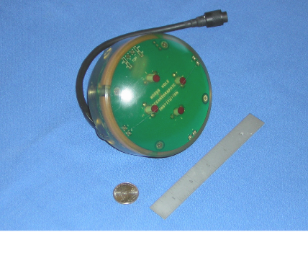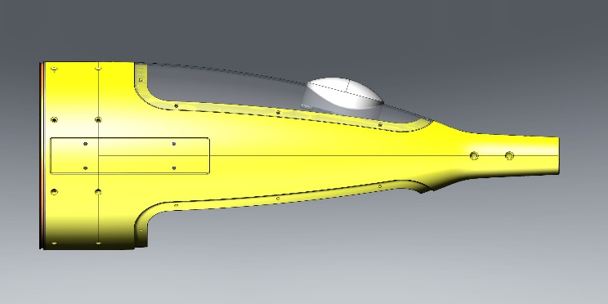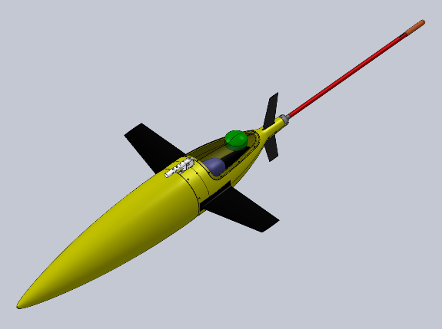

Figure 3: (left) Seaglider showing iUSBL mounted in the upper panel of the aft fairing. (center) Photograph of a prototype of the iUSBL array. (right) Close up of the aft fairing showing the iUSBL head mounted at a 16º tilt to reduce drag and improve navigation during descent to enable precise targeting of seafloor features.

*Seaglider software integration:* The iUSBL requires a custom instrument driver on Seaglider that enables two-way communication and grants the iUSBL the ability to affect basic glider operations. With existing funds we are developing a basic instrument driver that logs position fixes from the iUSBL and provides glider depth back to the unit (the additional constraint provided by depth enables a more precise position fix. For the effort proposed here, we will upgrade that driver to enable real-time updates from the iUSBL to the Seaglider’s on board position estimate, and allow data input from the iUSBL (position fixes) to trigger an update to Seaglider’s flight profile and trajectory. Seaglider has previously used a Micromodem with a similar custom driver to command the glider to come to the surface mid-dive. We expect to leverage that architecture for this project.

*Seep plume sensor integration onto Seaglider:* We will equip both Seagliders with Franatech METS methane sensors, sensors demonstrably suited to the detection of seep plumes in the water column and to low power operation on an AUG (Fig. 2; [Aleseamar, 2017]). We will additionally equip the gliders with AMT GmbH Redox potential (ORP) probes, on the basis of having measured redox anomalies with AUV Sentry over seep sites and used those anomalies to guide further sampling [unpublished data]. The METS and ORP data will be uploaded over Iridium at surfacings for visualization by operators. Integration of the METS and ORP sensors is straightforward. Located on the aft fairing panel, they will require only appropriate cabling and basic instrument drivers for logging.

*Waveglider:* A Waveglider SV3 will act as the surface expression of the system. The system exists now—during fieldwork in May of 2018 we will operate it as a mobile gateway buoy for the Sentry AUV. The proposed work will employ the same payload. The Waveglider carries a WHOI Micromodem, a 10 kHz amplifier and transducer, and a passthrough telemetry system that permits bi-directional Iridium-to-acoustic communication from shore. The modem, amplifier and transducer reside within a streamlined pod attached to the Waveglider’s lower unit (the “sub”) to reduce the impact of surface noise.

*Coordination algorithm:* The motions of the Waveglider and two Seagliders will be coordinated autonomously such that the team as a whole executes a survey plan defined at a high level by human operators, while retaining acoustic contact with one another, and moving to reestablish contact in the event of loss. The vehicles will be coordinated in a master/slave configuration with the Waveglider acting as master and the AUGs executing profiles in close proximity. The objective of the coordination algorithm portion of this proposal is to develop robust coordination strategies that allow for high-level user-friendly control of the robot team. The algorithms will permit users to specify survey plans as a single trajectory for the team, parameterized by along-track profile density and across-track width (Fig. 4).

Acoustic communications between the Waveglider and AUGs are uni-directional, thus the Waveglider can have no information on AUG positions during their dives. However, so long as the AUGs remain in acoustic contact, the AUGs know both their position, from iUSBL navigational aiding, and that of the Waveglider. This fact allows the AUGs to modify their trajectories subsea to maintain acoustic contact and to respond to alterations in target waypoints encoded within the acoustic navigation packets transmitted from the Waveglider.

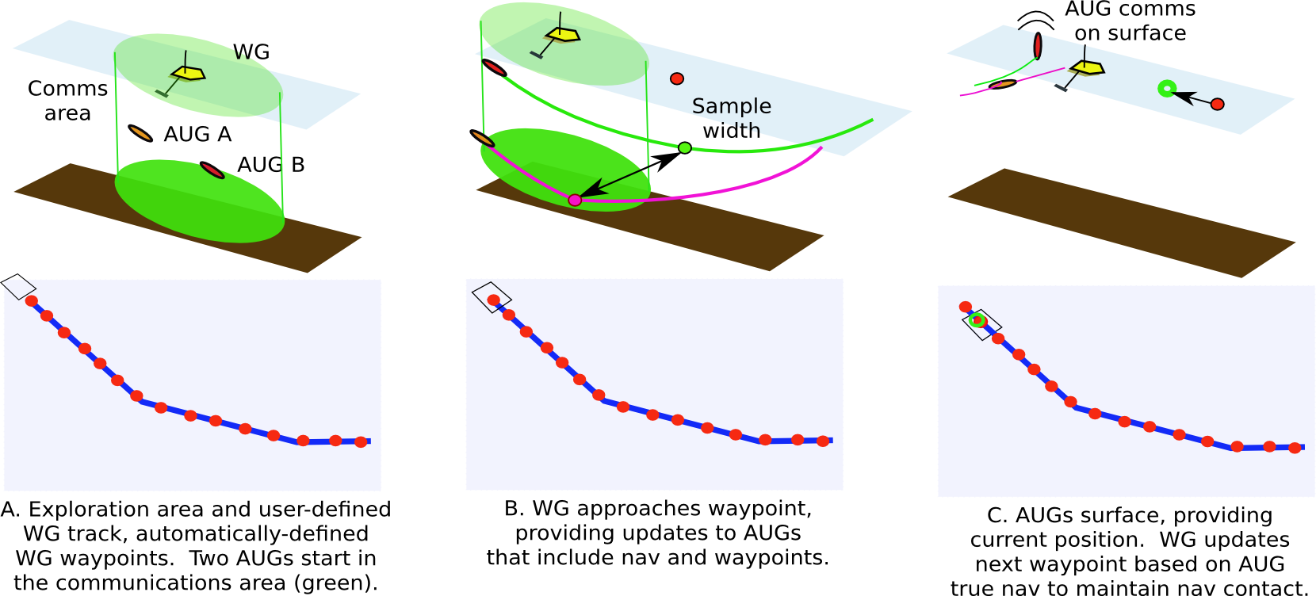

Figure 4: Possible vehicle coordination scheme including two AUGs and a WG, with change of WG waypoints based on changes in glider track during sampling.

Target waypoints for the AUGs could require updating during dives for several reasons. Human operators may decide to alter the overall trajectory of the survey or the coordination algorithm may dictate changes to the plan to accommodate the unexpected surfacing of an AUG outside of acoustic communication range. In this case the surface GPS fixes for the errant AUG will be used by the coordination algorithm to compute rendezvous trajectories for all vehicles in the team (one of which will generally be submerged in this event and will receive its updated instructions acoustically), resulting in temporary abandonment of the survey plan.

The central coordination algorithm will run on shore, with a web-based graphical user interface to permit monitoring and control of the team remotely by multiple geographically dispersed operators, and will handle all necessary non-emergency interactions with the Seaglider and Waveglider management softwares. The subsea (slave) component of the coordination algorithm will be implemented on the iUSBL Micromodems installed in the Seagliders as described above.

We will develop a simulator that includes dynamical models for the Seaglider [Eriksen et al, 2001] and Waveglider [Ngo et al., 2014; Smith et al., 2011], and with which to test candidate coordination algorithms. Our approach is to treat coordination of the robot team as an optimization problem, driven by a cost function that trades the risk of losing acoustic contact with an AUG against deviating from the survey plan. As we transition from development activities to implementation in year 2 of the project, we shall perform hardware-in-the-loop simulations and engineering tests with the algorithms running in real time.

*On-board and post-processed navigation:* Seaglider typically has no direct measure of its speed through the water or the water velocity itself. Instead, a hydrodynamic model, based pitch and either buoyancy and vertical velocity, is used to calculate the expected glide slope (pitch minus angle of attack) and forward velocity. The glider slope, forward velocity, and heading are combined in a process referred to as dead reckoning to estimate the glider’s position while subsea. The lift and drag parameters of the hydrodynamic model for a particular glider are estimated by the glider pilot during the first few dives of each deployment using various regression analyses and uploaded to the vehicle to enable accurate hydrodynamic calculation. These calculations, however, assume steady state flight through still water. Seaglider does typically spend the majority of its dive in steady state flight, but the current profile through which it is glides is unknown and causes a discrepancy between the model-based position estimate and the actual position. Once at the surface, this discrepancy---the difference between the expected surface location and the actual surface location---is typically used along with the length of the dive to provide an estimate of the *depth-averaged current*. This is a single number per dive that represents a vertically, horizontally, and temporally averaged current for up to a 1000m deep, multi-kilometer long, and 6 hour duration dive. In post processing this depth-averaged current can be used to correct the glider’s track, but, without prior information on the current profile, the current correction is applied uniformly across all depths, which is typically not representative of reality.

With the iUSBL, we will be able to estimate Seaglider’s actual georeferenced position while subsea, instead of simply relying on the dead-reckoned position. For real-time navigation, this will be used in two ways. While subsea, Seaglider typically attempts to keep on a specific heading, which is determined at the start of each dive, based on the relative bearing from the glider to the waypoint (optionally taking into account expected set and drift from current). With the iUSBL data, we will be able to recalculate and update the desired heading for the dive in real time based on the calculated bearing to the waypoint. In post processing, the iUSBL data will be fused with the attitude, depth, hydrodynamic, and GPS data using a Kalman filter [Webster et al., 2014] and a Rauch-Tung-Striebel smoother [Rauch et al., 1965] to produce our best estimate of subsea glider position.

In addition to improving our position estimates, the availability of subsurface position corrections enables us to look at navigation error accrued over smaller segments of the dive (i.e., between position fixes), and attribute that error to the effect of current in the appropriate depth band. A coarse implementation of this method is described in [Webster et al., 2015], using position updates provided by a series of individual range measurements received once every four hours. With the iUSBL having a maximum update rate of approximately one fix every 30 seconds, we will have significantly more position data to work with. One of the goals of this work is to investigate how well (in both accuracy and depth resolution) we are able to estimate the subsea current profile, using a combination of position fixes, Doppler measurements from the iUSBL, and acceleration data from the Sparton AHRS. Current profiles generated this way, resolved in both time and depth, will directly measure the spatio-temporal variability of seep plumes, a capability that has important implications for the ecoology and connectivity of benthic seep communities.

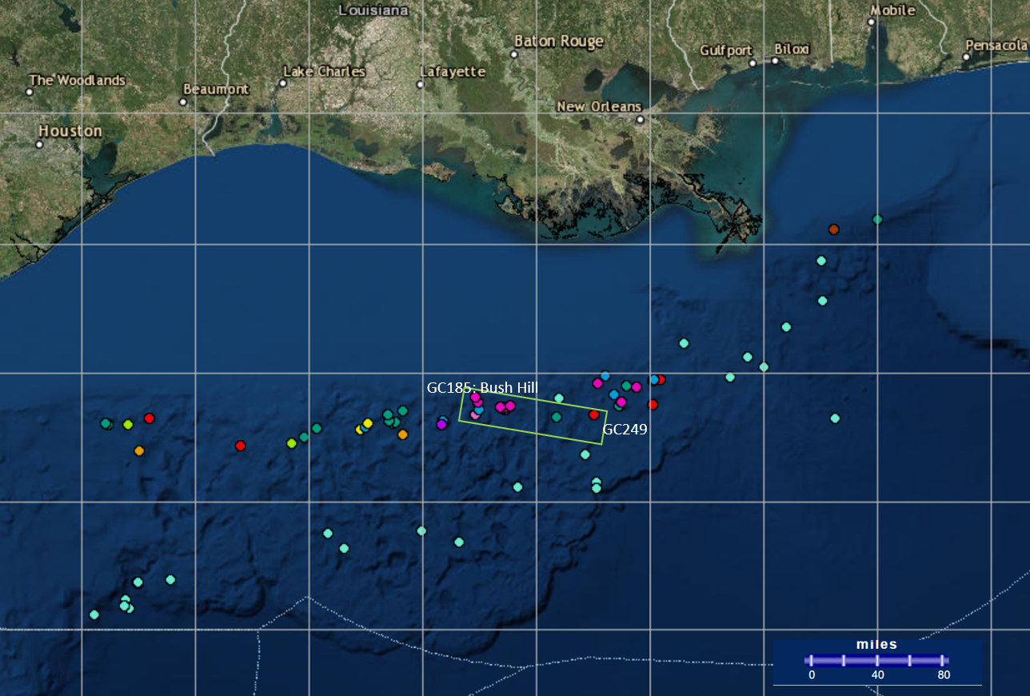

Figure 5: Northern Gulf of Mexico cold seep sites with approximate area of operation highlighted in green. Figure generated using the NOAA Gulf of Mexico data atlas, https://www.ncddc.noaa.gov/website/DataAtlas.

*System performance evaluation:* Following our field program we will generate performance statistics for the system that quantify system performance in terms of navigation quality, the ability of the system to deliver profiles at the desired density and along the desired trajectory versus survey parameters and environmental factors (currents, sea state), and the ability of the system to recover from loss of acoustic contact between the vehicles. We will examine to what extent our simulation is able to predict these outcomes. A calibrated simulation will allow us to extrapolate system performance to future exploration missions.

### Field Program

We have selected the Green Canyon region on the continental margin of the northwestern Gulf of Mexico as a field site because it is both readily accessible and arguably hosts the best studied seep sites in the world [Kennicutt, 2017]. The availability of groundtruth in the form of known seep sites is valuable because it provides for a direct comparison with our results: i.e., were signatures from all known seeps within the survey area present in the data, how accurately could seep location be discerned from the data, and what was the impact of increased sample density? The value of groundtruth notwithstanding, the number of surface oil slicks associated with natural seeps [MacDonald et al., 2015] significantly exceeds the number of known sites in the area (90 were known to host chemosynthetic communities as of 2007 [Fisher et al., 2007]), so there is potential for new discoveries even in this relatively well-studied region of the Gulf.

Our field program calls for a total deployment duration of one month. Consistent with our objectives, with the exception of day trips to deploy and recover the robotic assets at the beginning and end of this window, our field program requires no ship. At the nominal Seaglider survey speed of 20 km per day and 6 hours per round-trip profile to 1000 m (each profile includes a horizontal transit of approximately 5 km), we expect a total of 240 profiles (120 per Seaglider) over a maximum of 1200 km of total transect. Both AUG performance and the constraints of the iUSBL system factor into achievable spatial profile density. The minimum profile density, for a system with 2 Seagliders diving to 1000 m, is 1 profile per 3 km2 on a straight-line transect. Part of our field program will be devoted to validating this prediction for maximum straight-line transect speed. We will further establish maximum verifiable (navigated) sampling density over a known seep site. Most importantly, upon the identification of water column anomalies in transect data telemetered ashore, we will alter the desired spatial sampling density of the system to attempt localization of the seafloor source. A key deliverable from our fieldwork will be the accuracy with which our system is able to localize known sources relative to groundtruth. The expected division of time between these activities is 3 days/6 days/21 days.

We will deploy and recover the two Seagliders and Waveglider SV3 during two extended day trips one month (30 days) apart. Deployments and recoveries will coincide with the 500 m contour approximately due south of Louisiana Universities Marine Consortium’s (LUMCON’s) Cocodrie, LA facilities. Deployment at the 500 m contour is important to avoid the potential for lengthy delays in transit inherent to maneuvering the Seagliders in shallow water. LUMCON’s R/V Acadiana has sufficient range, speed and berthing to allow for transiting to the 500 m contour, deploying or recovering several assets and returning to port within 24 hrs. As recovery may involve more significant transits we have allowed for 2 additional days of vessel usage. All vehicles and the team as a whole will be managed via satellite from our home offices between deployment and recovery.

### Contributions of Participating Personnel

Jakuba will lead the effort, and has additional technical responsibilities as noted below. German and Jakuba have been using AUVs to localize hydrothermal venting since 2004. Together they will adapt proven hydrothermal plume mapping strategies to AUGs and seep plumes and develop the data processing and visualization methods necessary to manage the team from shore. Webster will provide two Seagliders to the project and oversee the installation of the iUSBL systems and water-column sensors specific to this work. Webster has developed acoustic navigation methods for gliders and will develop the algorithms to fuse OWTT-iUSBL data with existing model-based glider dead-reckoning, as well as oversee their implementation on the iUSBL system and the interface to the Seaglider control computer. Partan is an electronics and acoustics engineer on the OWTT-iUSBL system, and a lead engineer on the WHOI Micromodem acoustic modem. Partan will oversee the implementation of navigation and the subsea component of the coordination algorithms on the iUSBL Micromodem’s processor. He will also provide the project with expertise on array performance, acoustic propagation and range limitations as they apply to multi-vehicle coordination. Fischell has developed a shallow water OWTT-iUSBL system, independent from the deep-water system for use in the present work, and has employed the system to manage a multi-vehicle team of AUVs. She and Jakuba will develop the coordination algorithms and the simulation environment necessary to verify them, with input from Webster on Seaglider dynamics. They, with support from a software engineer, will be responsible for implementing the shore-side component of the coordination algorithm, user interface, and interfaces to the existing Waveglider and Seaglider management infrastructure. Jakuba, Partan, and a field engineer from UW will travel to Cocodrie for deployment and recovery. All PIs will participate in the field program, remotely, via satellite.

### Complementary Funding

This project leverages substantial complementary funding totaling $827704. This represents a 1.2x leveraging of the requested NOAA funds:

* Our existing NSF-funded effort to develop the iUSBL navigation system, the key enabling technology in the proposed effort, is funded at the level of $650,680.
* WHOI is investing $177,024 in a 2018 demonstration of ASV/AUV tending using the Sentry AUV and the same SV3 Waveglider and acoustic payload that will be used for the proposed work. While the constraints on inter-platform coordination between an ASV and multiple AUGs are substantially different in character, this demonstration will lay critical infrastructure for interfacing automatically with both the Waveglider and the acoustic pass-through payload to the submerged AUGs.

In addition, two Seagliders (UW) and one Waveglider (WHOI) are being provided to the project from UW and WHOI fee-free. Requested funds associated with these assets are limited to operations and sensor integrations costs.

### Availability of Ship Time

LUMCON makes R/V Acadiana available on a dayrate basis to external users. We have conferred with vessel managers at LUMCON to assure suitability of the Acadiana with respect to our field program and gear handling needs. Our project has no hard constraints and requires only readily accommodated isolated days.

### Anticipated outputs

* Demonstration of the capability to conduct water column exploration using teams of robots independent of a support ship and dissemination of the results via publications detailing the design and performance of the system.
* Two iUSBL modules and in situ chemical sensors integrated into Seagliders that will be available for use by us and collaborators in future proposals directed at exploration in the Gulf and elsewhere.
* A map of water-column seep activity in the Green Canyon area of the northern Gulf of Mexico continental margin, that may or may not indicate previously unknown seep sites, but will, at minimum, provide an indication of the extent of detectable reduced chemical species and methane in the water column associated with known seeps.

### Benefits to our nation’s understanding of the ocean and broader impacts

As a technology demonstrator, this project sets the stage for the recognition of AUGs as viable long-range deep ocean exploration vehicles. This is significant because AUGs have been widely adopted by the oceanographic community and exist in abundance. The exploration value of AUGs in the deep sea is greatly diminished without good navigation, but as this project will show, providing navigation aiding is possible with modest additional payload plus the teaming of vehicles with an ASV. The Waveglider ASV also enjoys wide adoption, therefore the potential is high for other researchers to adopt, and improve upon, the technology we will demonstrate.

Looking to the future, improved ability to discriminate water-column chemistry with in situ sensors and the potential of hybrid AUGs to expand the modalities of data that could be acquired will enable researchers to perform more complete site characterizations remotely, tasks that currently require the presence of a research vessel. Site characterizations, of seeps, hydrothermal vents, localized physical oceanographic phenomena such as flows around seamounts, and also of strictly seafloor features, perhaps identified in pre-existing bathymetric or sidescan maps, would become possible to accomplish remotely, and to accomplish in remote regions of the world ocean where the cost of sending ships is prohibitive.

### Outreach and education activities

The PIs hereby state their willingness to participate in OER outreach and education activities. We believe this project is particularly well-suited to the inspiration of future technologists and engineers, and anticipate contributions to the NOAA’s Ocean Explorer website will consist of at least schematic illustrations of the system concept and components, real-time updates to vehicle position during the field campaign for visualization on an interactive map, and a project narrative. Two berths are available on both the deployment and recovery day-trips and we would welcome the opportunity to host an educator-at-sea.

# Data Management Plan

This project will generate 4 primary types of data:

1. Seaglider observations of standard water column physical oceanographic parameters as well as of methane concentration and redox potential.
2. Waveglider observations of sea surface and meteorological conditions.
3. Positioning information for all vehicles, including both GPS and iUSBL position fixes.
4. Performance statistics for the system

Data types 1-3 will be archived with NOAA NCEI in accordance with the current NCEI netCDF templates for the “trajectory” and “trajectoryProfile” feature types. Data type 4 will appear in a publication at the conclusion of the project.

1. What types of environmental data types of other information will be created during this project?

*Above.*

1. What is the tentative date by which the data will be made publicly accessible?

*As this is a technology demonstrator project we have no incentive to delay public release of the data generated. The data shall be made available at the conclusion of the project.*

1. If the data are not to be shared, under what authority are you requesting an exemption?

*The data shall be shared.*

1. Where will data be hosted for public access?

*The data shall be hosted at NOAA NCEI.*

1. In what formats will the data be submitted?

*The data shall be submitted in accordance with the v.2 netCDF templates for “trajectory” and “trajectoryProfile” feature types*.

1. Will you provide metadata for the datasets or will you require assistance in doing so?

*We shall provide metadata embedded per usual practice in the netCDF file. Metadata shall consist of no less than contact information for PI Jakuba, the vehicle used including instrumentation installed, data processing steps, quality control procedures, deployment site, and objectives of the deployment.*

1. Can you provide an estimate of the total volumes of data to be archived by data type?

*As this project will produce no imagery the volume of data shall be small. We estimate a total data volume of less than 10 GB.*

1. Can you provide examples of prior experience in making such data accessible?

*We have participated in numerous NSF and NOAA cruises for which the data was made public. We have particular familiarity with National Deep Submergence Facility data policies and have served as both “customers” on the science side of NDSF facilities with ultimate responsibility for the timely release of data, and as facility operators responsible for processing, quality control, and archival of data from the ABE and Sentry AUVs.*

*We have not previously personally archived data with NCEI; however, Seaglider data has been archived by others and we have access to the same mechanisms. We are familiar with both reading and writing netCDF files, have examined the v.2 data templates, and believe that it shall be straightforward to provide both Seaglider and Waveglider data in compliant form.*

# Summary of Significant Results and Achievements of the PIs

PI Jakuba has participated in 30 deep water cruises, 6 as expedition leader and served as the lead engineer on the development of two recent large ocean robots, the *Nereid Under Ice* (NUI) and *Clio* vehicles. As a graduate student with the ABE AUV operations team he sailed with Co-PI German during the first successful use of an AUV for hydrothermal prospecting, in the Lau Basin in 2014. Since then as has developed fully autonomous as well as supervised methods for geophysical plume survey, including work with the Sentry AUV during the response to the Deepwater Horizon disaster, with on-going work to translate terrestrial methods to outer solar system ocean worlds. He has been supported (unnamed) by NOAA OER funding as expedition leader during the first NUI deployments beneath ice, in the High Arctic at 82° N [McFarland et al., 2015; Katlein et al., 2015].

Co-PI Webster is an Senior Engineer with broad experience with oceanographic sensors, remotely operated and autonomous vehicle systems, and algorithm development, including specifically distributed acoustic navigation. She is very familiar with Seaglider control and operations, and has worked extensively on navigation algorithms for Seagliders.

Co-PI Partan is an electronics and acoustics engineer on the OWTT-iUSBL system, and a lead engineer on the WHOI Micromodem acoustic modem. He has extensive experience with the fielding of acoustic communications systems on board autonomous platforms, including Wavegliders and Seagliders.

Co-Pi Fischell he is currently an assistant scientist in the Applied Ocean Physics and Engineering (AOPE) department at WHOI and has more than 10 years experience building AUVs and AUV acoustics and environmental sensing payloads. Fischell's research interests include real-time acoustic data processing, autonomous adaptation, machine-learning-based feature detection and classification, low-cost AUV navigation, and multi-vehicle autonomy. She has developed a shallow water OWTT-iUSBL system, independently from the deep-water system for use in the present work, and presently uses the system to navigate a multi-vehicle team of AUVs devoted to robotics research.

Co-PI German has participated in more than 60 deep water research and exploration cruises, often as Chief Scientist, including many that have discovered and explored new seafloor fluid flow (hydrothermal vent and cold seep) sites. He served as Chief Scientist for the National Deep Submergence Facility for more than eight years and, in addition to his geochemical expertise, has helped pioneer the use of advanced robotics in seafloor exploration. Over the past decade, German has been funded on several NOAA OER grants including, most recently, on a project to develop tools for ocean co-exploration (to commence in 2018), and as Lead PI for the first NUI under-ice dives in the Arctic, in Summer 2014, discussed above. His NOAA-OER projects include cruises with the ABE AUV in 2005 and 2006 that explored for and dived on the first vents to be located anywhere in the South Atlantic [Haase et al., 2007; German et al., 2008; Melchert et al., 2008; Hasse et al., 2009; Walter et al., 2010]. With the advent of Telepresence, German also led the first Okeanos Explorer cruise (EX11-04 to the mid-Cayman Rise) that provided continuous outreach broadcast via the internet [German et al., 2012; Bennet et al., 2013], and the first Okeanos Explorer cruise (EX12-05) to include AUV operations (a joint NSF-NOAA cruise using AUV Sentry at Blake Spur) in Summer 2012 [Brothers et al., 2013; Wagner et al., 2013].

# 

# 

# References Cited

Allen, B., R. Stokey, N. Forrester, R. Goldsborough, M. Purcell, and C. von Alt. REMUS: A small, low cost AUV; system description, field trials and performance results. In Proc. IEEE/MTS OCEANS Conf. Exhib., volume 2, pages 994-1000, October 1997.

[Alseamar, 2017] “Drone Images ocean methane seeps.” Offshore magazine, 09/2017. http://www.offshore-mag.com/articles/2017/09/drone-images-ocean-methane-seeps.html

Archer, D., Buffett, B. & Brovkin, V. Ocean methane hydrates as a slow tipping point in the global carbon cycle. Proc. Natl Acad. Sci. USA 106, 20596–20601 (2009).

Audric, M. GAPS, a new concept for USBL. In Ocean '04 - MTS/IEEE Techno-Ocean '04: Bridges across the Oceans - Conference Proceedings, volume 2, pages 786{788, Kobe, Japan, November 2004.

E.T.Baker & C.R.German. On the global distribution of mid-ocean ridge hydrothermal vent-fields. *In* "The Thermal Structure of the Oceanic Crust and the Dynamics of Seafloor Hydrothermal Circulation", *Geophysical Monograph* 148, 245-266, 2004.

E.T.Baker, J.A.Resing, R.M.Haymon, V.Tunnicliffe, J.W.Lavelle, F.Martinez, V.Ferrini, S.L.Walker and K.Nakamura. How many vent sites? New estimates of vent field populations on ocean ridges from precise mapping of hydrothermal discharge locations. Earth Planet. Sci. Lett. 449, 186-196., 2016.

S.E.Beaulieu, E.T.Baker, C.R.German & A.Maffei. An authoritative global database for active submarine hydrothermal vent fields. *Geochem. Geophys. Geosystems* 14, 4892–4905, 2013*.*

S.E.Beaulieu, E.T.Baker & C.R.German. Where are the undiscovered hydrothermal vents on oceanic spreading ridges? *Deep Sea Res. II* 121, 202-212*,* 2015.

Bellingham, J.G., B. Hobson, M. A. Godin, B. Kieft, J. Erikson, R. McEwen, C. Kecy, Y. Zhangand T. Hoover, and E. Mellinger. A small, long-range AUV with flexible speed and payload. In Ocean Sciences Meeting, 2010.

S.A.Bennett, M.Coleman, J.Huber, E.Reddington, J.Kinsey, C.McIntyre, J.Seewald & C.R.German. Carbon cycling in a dispersing hydrothermal plume from an ultramafic hosted system on the Mid Cayman Rise. Geochem. Geophys. Geosyst. 14, 317-327, 2013.

Biastoch, A. et al. Rising Arctic Ocean temperatures cause gas hydrate destabilization and ocean acidification. Geophys. Res. Lett. 38, L08602 (2011).

Bradley, A.M. and D. R. Yoerger. Design and testing of the Autonomous Benthic Explorer. In Proceedings of AUVS '93, 1993.

Brokloff, N.A. Dead reckoning with an ADCP and current extrapolation. In Proceedings of IEEE/MTS Oceans Conference, volume 2, pages 994-1000, Halifax, NS, Canada, October 1997.

Brothers, L., C. Van Dover, C. German, C. Kaiser, D. Yoerger, C. Ruppel, E. Lobecker, A. Skarke, and J. Wagner (2013), Evidence for extensive methane venting on the southeastern US Atlantic margin, Geology, 41(7), 807-810. doi: 10.1130/G34217.1

R. Camilli. “HC-Sentinel: An AUV Glider for High Endurance Subsea Hydrocarbon Detection.” Final report submitted to the Bureay of Safety and Environmental Enforcement Oil Spill Response Research Branch. Jan 23, 2017. https://www.bsee.gov/sites/bsee.gov/files/research-reports//1041aa.pdf

Claus, B, R. Bachmayer, and C.D. Williams. Development of an auxiliary propulsion module for an autonomous underwater glider. Proceedings of the Institution of Mechanical Engineers, Part M: Journal of Engineering for the Maritime Environment, 224(4):255-266, 2010.

Claus B, Bachmayer R, Cooney L. Analysis and development of a buoyancy-pitch based depth control algorithm for a hybrid underwater glider. In Autonomous Underwater Vehicles (AUV), 2012 IEEE/OES 2012 Sep 24 (pp. 1-6). IEEE.

Claus B, Bachmayer R. Terrain‐aided Navigation for an Underwater Glider. Journal of Field Robotics. 2015 Oct 1;32(7):935-51.

Claus B, Bachmayer R. A parameterized geometric magnetic field calibration method for vehicles with moving masses with applications to underwater gliders. Journal of Field Robotics. 2017 Jan 1;34(1):209-23.

Corliss, J.B., J. Dymond, L. Gordon, J.M. Edmond, R.P. von Herzen, R.D. Ballard, K. Green, D. Williams, A. Bainbridge, K. Crane, and T.H. Van Adel. 1979. Submarine thermal springs on the Galapagos Rift. Science 203:1073-1083.

C. C. Eriksen *et al*., "Seaglider: a long-range autonomous underwater vehicle for oceanographic research," in *IEEE Journal of Oceanic Engineering*, vol. 26, no. 4, pp. 424-436, Oct 2001.

Feseker T, Boetius A, Wenzhöfer F, Blandin J, Olu K, Yoerger DR, Camilli R, German CR, De Beer D. Eruption of a deep-sea mud volcano triggers rapid sediment movement. Nature communications. 2014 Nov 11;5.

E. Fiorelli, N. E. Leonard, P. Bhatta, D. A. Paley, R. Bachmayer and D. M. Fratantoni, "Multi-AUV Control and Adaptive Sampling in Monterey Bay," in *IEEE Journal of Oceanic Engineering*, vol. 31, no. 4, pp. 935-948, Oct. 2006.

Fisher CR, Hsing PY, Kaiser CL, Yoerger DR, Roberts HH, Shedd WW, Cordes EE, Shank TM, Berlet SP, Saunders MG, Larcom EA. Footprint of Deepwater Horizon blowout impact to deep-water coral communities. Proceedings of the National Academy of Sciences. 2014 Aug 12;111(32):11744-9.

E. M. Fischell, N. Rypkema and H. Schmidt. “Relative Acoustic Navigation for Sensing with Low-Cost AUVs.” ICRA 2016 Workshop on Marine Robot Localization and Navigation, May 20, 2016. (avail. <http://icra2016.csail.mit.edu/navigation-localization-workshop/abstracts/05_Fischell_ICRAworkshop_abstract.pdf>).

Fisher C, Roberts H, Cordes E, Bernard B. Cold seeps and associated communities of the Gulf of Mexico. Oceanography. 2007 Dec 1;20(4):118-29.

L.Freitag, M.Grund, J.Partan, S.Singh, P.Koski & K.Ball. The WHOI Micro-Modem: An Acoustic Communications and Navigation system for Multiple Platforms. Proc. IEEE Oceans 2005, Washington, D.C. Sept. 2005.

L.Freitag, K.Ball, J.Partan, P.Koski & S.Singh. Long Range Acoustic Communications and Navigation in the Arctic. IEEE Oceans 2015, Oct 2015, Washington DC.

Furlong, M.E., S.D. McPhail, and P. Stevenson. A concept design for an ultra-long-range survey class AUV. In OCEANS 2007 - Europe, pages 1-6, June 2007.

E.Gallimore, J.Partan, I.Vaughn, S.Singh, J.Shusta & L.Freitag. The WHOI Micromodem-2: A Scalable System for Acoustic Communications and Networking. Proc. IEEE Oceans 2010, Sept 2010.

Gardner AT and Collins JA. Advancements in high-performance timing for long term underwater experiments: A comparison of chip scale atomic clocks to traditional microprocessor-compensated crystal oscillators. InOceans, 2012 2012 Oct 14 (pp. 1-8). IEEE

C.R.German, S.A.Bennett, D.P.Connelly, A.J.Evans, B.J.Murton, L.M.Parson, R.D.Prien, E.Ramirez-Llodra, M.Jakuba, T.M.Shank, D.R.Yoerger, E.T.Baker, S.L.Walker & K.Nakamura. Hydrothermal activity on the southern Mid-Atlantic Ridge: Tectonically- and volcanically-controlled venting at 4-5°S. Earth Planet. Sci. Lett. 273, 332-344, 2008.

C.R.German, E.Z.Ramirez-Llodra, M.C.Baker, P.A.Tyler & the ChEss Scientific Steering Committee. Deep-water Chemosynthetic Ecosystem Research during the Census of Marine Life decade and beyond: A proposed deep-ocean road map. PLoS One 6, e23259, 2011.

C.R.German, M.V.Jakuba, J.C.Kinsey, J.Partan, S.Suman, A.Belani & D.R.Yeorger. A long term vision for long-range ship-fre deep ocean operations: persistent presence through coordination of Autonomous Surface Vehicles and Autonomous Underwater Vehicles. Paper presented at IEEE-AUV 2012 Conference, 7pp, 2012.

C.R.German, P.A.Tyler, C.McIntyre, D.Amon, M.Cheadle, J.Clarke, B.John, J.McDermott, S.Bennett, J.Huber, J.Kinsey, J.Seewald, C.Van Dover & K.Elliott. Exploration of the Mid-Cayman Rise. Oceanography 25, 52-53, 2012.

German CR, Petersen S, Hannington MD. Hydrothermal exploration of mid-ocean ridges: Where might the largest sulfide deposits be forming?. Chemical Geology. 2016 Jan 20;420:114-26.

G. Griffiths. Autosub under ice. Ingenia, 22:30-32, 2005.

K.M.Haase, S.Petersen, A.Koschinsky, R.Seifert, C.W.Devey, R.Keir, K.S.Lackschewitz, B.Melchert, M.Perner, O.Schmale, J.Süling, N.Dubilier, F.Zielinski, S.Fretzdorff, D.Garbe-Schönberg, U.Westernströer, C.R.German, T.M.Shank, D.Yoerger, O.Giere, R.Keir, J.Kuever, K.Lackschewitz, J.Mawick, H.Marbler, B.Melchert, C.Mertens, J.Kuever, H.Marbler, J.Mawick, C.Mertens, U.Stöber and M.Walter. Young volcanism and related hydrothermal activity at 5°S on the slow-spreading southern Mid-Atlantic Ridge. Geochem., Geophys., Geosystems 8, Q11002, doi: 10.1029/2006GC001509, 2007.

K.M.Haase, A.Koschinsky, S.Petersen, C.W.Devey, C.German, K.S.Lackschewitz, B.Melchert, R.Seifert, C.Borowski, O.Giere, H.Paulick and the M64/1, M68/1 & M78/2 Scientific Parties. Diking, young volcanism and diffuse hydrothermal activity on the southern Mid-Atlantic Ridge: the Lilliput fields at 9°33’S. Mar. Geol. 266, 52-64, 2009.

K.P.Hand & C.R.German. Exploring ocean worlds on Earth and beyond. Nature Geoscience, in press.

Hine, R.; Willcox, S.; Hine, G.; Richardson, T. In The wave glider: A wave-powered autonomous marine vehicle, OCEANS 2009, MTS/IEEE Biloxi-Marine Technology for Our Future: Global and Local Challenges, 2009; IEEE: 2009; 6 pp.

Mary M. Hunt, William M. Marquet, Donald A. Moller, Kenneth R. Peal, Woolcott K. Smith, and Robert C. Spindell. An acoustic navigation system. Technical Report WHOI-74-6, Woods Hole Oceanographic Institution, Woods Hole, Massachusetts 02543 USA, December 1974.

Jakuba MV, Kinsey JC, Partan JW, Webster SE. Feasibility of low-power one-way travel-time inverted ultra-short baseline navigation. InOCEANS'15 MTS/IEEE Washington 2015 Oct 19 (pp. 1-10). IEEE.

C. Katlein, S. Arndt, M. Nicolaus, D. K. Perovich, M. V. Jakuba, S. Suman, S. E. andLouis L. Whitcomb, C. J. McFarland, R. Gerdes, A. Boetius, and C. R. German. Influence of ice thickness and surface properties on light transmission through Arctic sea ice. J. Geophys. Res. Oceans, 120:1-13, Sept. 2015. doi:10.1002/2015JC010914.

Kennicutt M.C. (2017) Oil and Gas Seeps in the Gulf of Mexico. In: Ward C. (eds) Habitats and Biota of the Gulf of Mexico: Before the Deepwater Horizon Oil Spill. Springer, New York, NY

Kinsey, James C. and Louis L. Whitcomb. Preliminary field experience with the DVLNAV integrated navigation system for oceanographic submersibles. Control Engineering Practice, 12(12):1541-1548, December 2004.

Kinsey, James C., Dana R. Yoerger, Michael V. Jakuba, Rich Camilli, Charles R. Fisher, and Christopher R. German. Assessing the Deepwater Horizon oil spill with the Sentry autonomous underwater vehicle. In Proceedings of the IEEE International Conference on Robotics and Systems, pages 261{267, September 2011.

Leonard, N. E., Paley, D. A., Davis, R. E., Fratantoni, D. M., Lekien, F. and Zhang, F. (2010), Coordinated control of an underwater glider fleet in an adaptive ocean sampling field experiment in Monterey Bay. J. Field Robotics, 27: 718–740.

Levin, L.A., Baco, A.R., Bowden, D.A., Colaco, A., Cordes, E.E., Cunha, M.R., Demopoulos, A.W., Gobin, J., Grupe, B.M., Le, J. and Metaxas, A., 2016. Hydrothermal vents and methane seeps: rethinking the sphere of influence. *Frontiers in Marine Science*, *3*, p.72.

MacDonald, I.R., Garcia‐Pineda, O., Beet, A., Daneshgar Asl, S., Feng, L., Graettinger, G., French‐McCay, D., Holmes, J., Hu, C., Huffer, F. and Leifer, I., 2015. Natural and unnatural oil slicks in the Gulf of Mexico. Journal of Geophysical Research: Oceans, 120(12), pp. 8364-8380.

C. McFarland, M. Jakuba, S. Suman, J. Kinsey, and L. Whitcomb. Toward ice-relative navigation of underwater robotic vehicles under moving sea-ice: Experimental evaluation in the Arctic Sea. In IEEE International Conference on Robotics & Automation, page 6 pp., 2015.

McGinnis, D. F., Greinert, J., Artemov, Y., Beaubien, S. E. & Wuest, A. Fate of rising methane bubbles in stratified waters: How much methane reaches the atmosphere? J. Geophys. Res. 111, C09007 (2006).

C. Meinig, N. Lawrence-Slavas, R. Jenkins and H. M. Tabisola, "The use of Saildrones to examine spring conditions in the Bering Sea: Vehicle specification and mission performance," in Proc. IEEE/MTS OCEANS Conf. Exhib., Washington, DC, Oct 2015, pp. 1-6.

B.Melchert, C.W.Devey, C.R.German, K.S.Lackschewitz, R.Seifert, M.Walter, C.Ertens, D.R.Yoerger, E.T.Baker, H.Paulick & K.Nakamura. First evidence for high-temperature off-axis venting of deep crustal/mantle heat: the Nibelungen Hydrothermal Field, Southern Mid-Atlantic Ridge. Earth Planet. Sci. Lett. 275, 61-69, 2008.

Milne, P.H. Underwater Acoustic Positioning Systems. Gulf Publishing, Houston, 1983.

Ngo, P., Das, J., Ogle, J., Thomas, J., Anderson, W., & Smith, R. N. (2014, September). Predicting the speed of a wave glider autonomous surface vehicle from wave model data. In *Intelligent Robots and Systems (IROS 2014), 2014 IEEE/RSJ International Conference on* (pp. 2250-2256). IEEE.

Opderbecke, J. At-sea calibration of a USBL underwater vehicle positioning system. In Oceans Conference Record (IEEE), volume 1, pages 721{726, Halifax, NS, Canada, October 1997.

O'Reilly TC, Kieft B, Chaffey M. Communications relay and autonomous tracking applications for Wave Glider. InOCEANS 2015-Genova 2015 May 18 (pp. 1-6). IEEE.

T. J. Osse and C. C. Eriksen, "The Deepglider: A Full Ocean Depth Glider for Oceanographic Research," *OCEANS 2007*, Vancouver, BC, 2007, pp. 1-12.

D. A. Paley, F. Zhang and N. E. Leonard, "Cooperative Control for Ocean Sampling: The Glider Coordinated Control System," in *IEEE Transactions on Control Systems Technology*, vol. 16, no. 4, pp. 735-744, July 2008.

Parthiot, F.P and J.-F. Denis. A better way to navigate on deep sea floors. In OCEANS '93. 'Engineering in Harmony with Ocean'. Proceedings, Victoria, BC, 1993.

Paull, C.K., Hecker, B., Commeau, R., Freemanlynde, R.P., Neumann, C., Corso, W.P., Golubic, S., Hook, J.E., Sikes, E., and Curray, J., 1984, Biological communities at the Florida Escarpment resemble hydrothermal vent taxa: Science, v. 226, p. 965–967, doi:10.1126/science.226.4677.965.

Rauch, H.E.; Tung, F.; Striebel, C. T. (1965). "Maximum likelihood estimates of linear dynamic systems". AIAA Journal. 3 (8): 1445–1450.

Resing JA, Sedwick PN, German CR, Jenkins WJ, Moffett JW, Sohst BM, Tagliabue A. Basin-scale transport of hydrothermal dissolved metals across the South Pacific Ocean. Nature. 2015 Jul 9;523(7559):200-3.

Rypkema, N. R., Fischell, E. M., & Schmidt, H. One-Way Travel-Time Inverted Ultra-Short Baseline Localization for Low-Cost Autonomous Underwater Vehicles. IEEE ICRA 2017, 6 pp.

Singh, S., M. Grund, B. Bingham, R. Eustice, H. Singh, and L. Freitag. Underwater acoustic navigation with the WHOI Micro-Modem. In Proceedings of IEEE/MTS Oceans Conference, Boston, MA, September 2006.

Skarke, A., C. Ruppel, M. Kodis, D. Brothers, and E. Lobecker (2014), Widespread methane leakage from the sea floor on the northern US Atlantic margin, Nature Geoscience, 7(9), 657-661. doi:10.1038/ngeo2232.

Smith, RN, Jonathan Kelly, Yi Chao, Burton H. Jones, and Gaurav S. Sukhatme. Towards the improvement of autonomous glider navigational accuracy through the use of regional ocean models. In Proceedings of the ASME 29th International Conference on Ocean, Offshore and Arctic Engineering, pages 597{606. ASME, Ocean, Offshore, & Arctic Engineering Div., 2010.

Smith, R. N., Das, J., Hine, G., Anderson, W., & Sukhatme, G. S. (2011, September). Predicting wave glider speed from environmental measurements. In *OCEANS 2011* (pp. 1-8). IEEE.

Smith , S.M. and D. Kronen. Experimental results of an inexpensive short baseline acoustic positioning system for AUV navigation. In Proceedings of IEEE/MTS Oceans Conference, pages 714-720, Halifax, NS, Canada, October 1997.

Stommel, H. The Slocum mission. Oceanography, 2(1):22{25, 1989.

Valentine DL, Reddy CM, Farwell C, Hill TM, Pizarro O, Yoerger DR, Camilli R, Nelson RK, Peacock EE, Bagby SC, Clarke BA. Asphalt volcanoes as a potential source of methane to late Pleistocene coastal waters. Nature Geoscience. 2010 May 1;3(5):345-8.

Wagner, J.K., M.H. McEntee, L.L.Brothers, C.R.German, C.L.Kaiser, D.R.Yoerger & C.L.Van Dover. Cold-seep habitat mapping: high resolution spatial characterization of the Blake Ridge Diapir seep field. *Deep Sea Res*. 92, 183-188, 2013.

M.Walter, C.Mertens, U.Stöber, C.R.German, D.R.Yoerger, J.Sültenfuss, M.Rhein, B.Melchert & E.T.Baker. Rapid dispersal of a hydrothermal plume by turbulent mixing. Deep Sea Res. 57, 931-945, 2010.

D. C. Webb, P. J. Simonetti and C. P. Jones, "SLOCUM: an underwater glider propelled by environmental energy," in *IEEE Journal of Oceanic Engineering*, vol. 26, no. 4, pp. 447-452, Oct 2001.

S. E. Webster, C. M. Lee, and J. I. Gobat, “Preliminary results in under-ice acoustic navigation for Seagliders in Davis Strait,” in Proc. IEEE/MTS OCEANS Conf. Exhib., St. John’s, Newfoundland, Sept. 2014, pp. 1–5.

S. E. Webster, L. E. Freitag, C. M. Lee and J. I. Gobat, "Towards real-time under-ice acoustic navigation at mesoscale ranges," in Proc. IEEE Int’l. Conf. Robot. Autom. (ICRA), Seattle, WA, 2015, pp. 537-544.

Whitcomb L.L., D.R. Yoerger, and H. Singh. Advances in Doppler-based navigation of underwater robotic vehicles. In Proceedings of the IEEE International Conference on Robotics and Automation, volume 1, pages 399-406, Detroit, Michigan, May 1999.

Zapata LM, Mallios A, Ridao P, Camilli R, Pizarro O. Preliminary results on terrain-aided localization algorithm for glider AUV. In proceedings of the *IEEE Internation Conference on Robotics and Automation,* 2016.